**Case study of “Shiv Shakti Rice Mill”**

**Final Term report for the BDM capstone Project**

**Submitted by**

**Name: Digpal Singh**

**Roll number: 21F3001362**



IITM Online BS Degree Program,

Indian Institute of Technology, Madras, Chennai

Tamil Nadu, India, 600036

**Contents:**

1. Executive Summary & Title

2. Detailed Explanation of Analysis Process / Methods

3. Results & Findings

4. Interpretation of Results & Recommendation

5. Conclusion

6. Important links

# Executive Summary:

“Shiv Shakti Mill Store” is a mid-sized Kirana store, started by Mr. Ramesh Yadav in early 2017, currently encountering challenges in terms of profit and inventory management which is having an indirect impact on the store's net profit and sales. The aim of the proposed capstone project is focused on the objective to understand the complexities of managing or controlling inventory/goods flow, enhancing the sales and formulating marketing strategies that increase net profit and sales of the store.

Considering objective, primary goal of our capstone project will be to increase net profit, optimization and checking inventory to determine the optimum purchase time and manage goods flow and expenditure as well. To achieve this, the project will necessitate an in-depth analysis of the sales data along with fluctuation in purchase price over the month. Identifying the gaps and areas of improvement in the current strategy will be a critical aspect of this project. The report will also include in depth analysis of the sales data to identify patterns and trends in the sales. This analysis will allow us to identify the best and worst performing items, enabling us to understand and formulate marketing strategies to improve net sales leading to an increase in net profit. After a thorough analysis, the project report will focus on recommendations to combat the problem areas as identified above.

To analyse the sales data and make indicated business decisions, I will be utilizing various Excel tools such as pivot tables, bar graphs, and line graphs etc ... that can provide valuable graphical representations. These tools enable a visual representation of the sales data, making it easier to identify trends, patterns, and key insights. By analysing the outperforming and underperforming products using these Excel tools, recommendation, marketing strategy and data-driven decisions to optimize revenue generation can be formulated.

# Detailed Explanation of Analysis Process/Method:

# Data Analysis for sales and expenditure:

As per aforesaid statement, MS Excel is the main tool which will be used for the analysis. First, sales data is collected in an unstructured format along with prices of each product from “Shiv Shakti Mill Store” over the period of approx. 31 days.

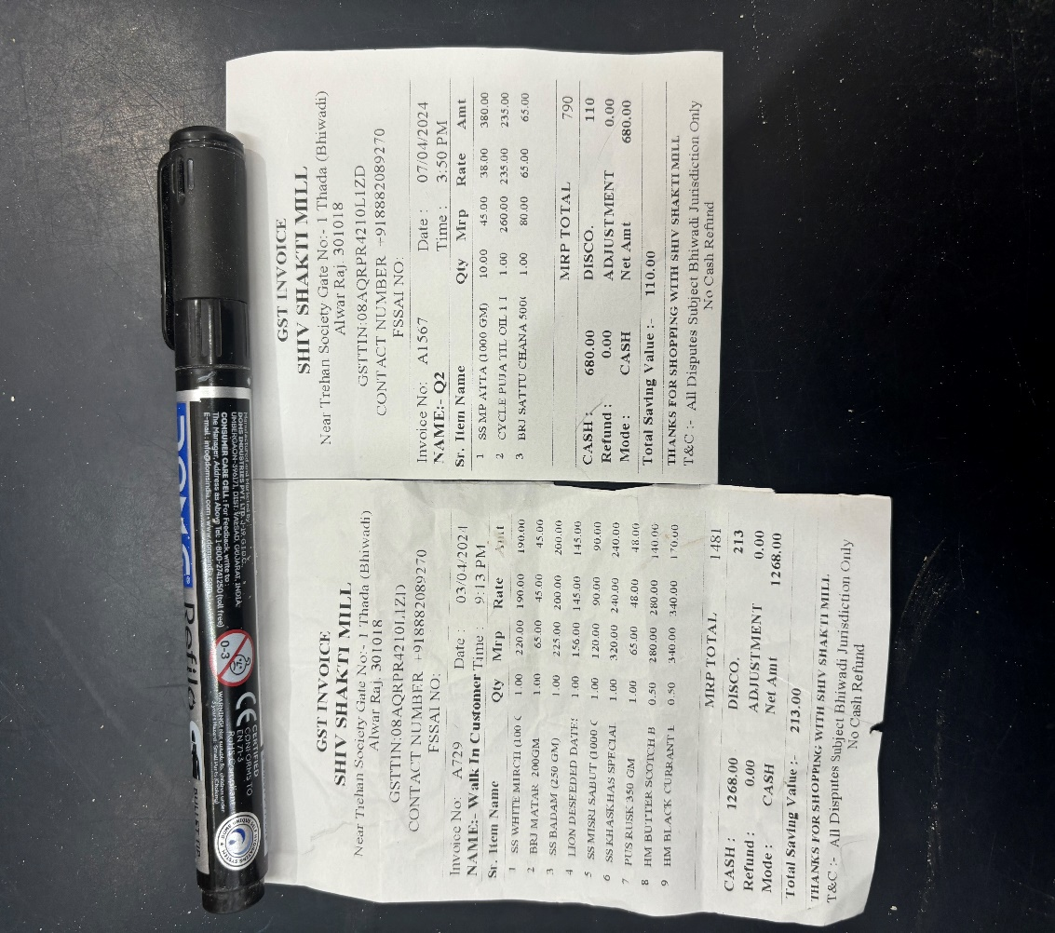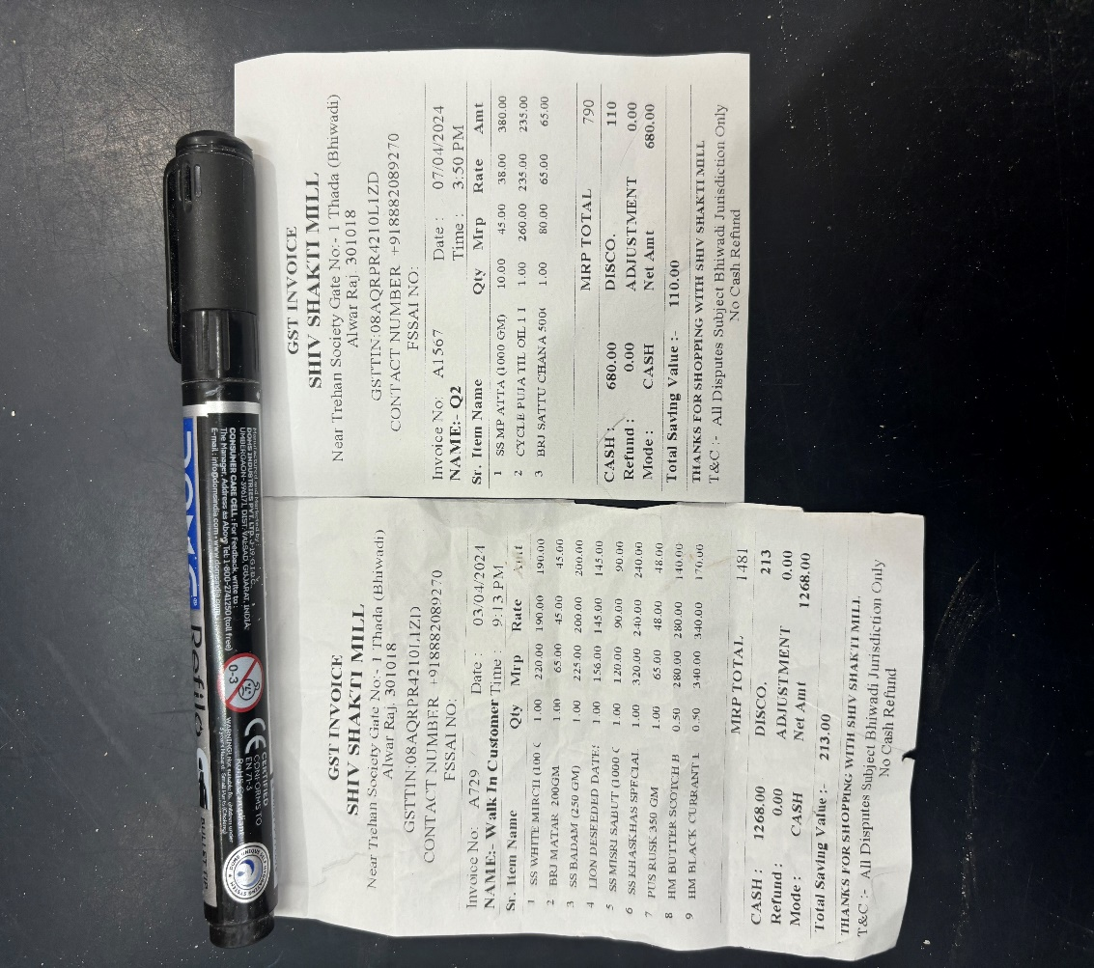

*Data storage way*

The unstructured store data inserted into excel and basic data pre-processing task such as typing errors, improper data standard, sorting etc. are done.

* The pre-processed sales data have a total of 31 columns where 15 columns represent each item’s sales quantity along with the date (1 column) and 10 more represent each item’s selling price on the given day.





* Using sales and selling price revenue for the day, average sales, selling price and total revenue can be calculated by formula:

𝑅𝑒𝑣𝑒𝑛𝑢𝑒 = 𝑆𝑒𝑙𝑙𝑖𝑛𝑔 𝑝𝑟𝑖𝑐𝑒 * 𝑆𝑎𝑙𝑒𝑠

𝑇𝑜𝑡𝑎𝑙 𝑅𝑒𝑣𝑒𝑛𝑢𝑒 =*i*

where = Revenue made at *ith* day

* In the same manner, purchase data has been collected for every item’s which consists of purchase quantity and purchase price, using which expenditure is calculated on each item.





* Then, expenditure, total expenditure, average expenditure per item and total expenditure is calculated using formulas as:

𝐸𝑥𝑝𝑒𝑛𝑑𝑖𝑡𝑢𝑟𝑒 = 𝑃𝑢𝑟𝑐ℎ𝑎𝑠𝑒 𝑄𝑢𝑎𝑛𝑡𝑖𝑡𝑦 * 𝑃𝑢𝑟𝑐ℎ𝑎𝑠𝑒 𝑃𝑟𝑖𝑐𝑒

*Total Expenditure* = *i*

*where = Expenditure at ith day*

# Increase the profit of the store:

* During store visit and my discussion with the store’s owner, we found that due to the entrance of new competitors and online grocery shops, profits were declining, which was not a good sign for them to survive.
* That’s why our first step was to figure out the profit / loss for each day, each item to determine the authenticity of the owner, for that I used sales and purchase data to calculate profit/loss, profit % for each item day using formula.

𝑃𝑟𝑜𝑓𝑖𝑡 = 𝑆𝑎𝑙𝑒𝑠 − 𝑃𝑢𝑟𝑐ℎ𝑎𝑠𝑒

*p𝑟𝑜𝑓𝑖𝑡*item % = (*p𝑟𝑜𝑓𝑖𝑡*item / 𝑇. 𝑝𝑟𝑜𝑓𝑖𝑡) %





* Since there was some inventory for every item at the start and end of data collection purchase of each item, was calculated using formula.

*𝑃𝑢𝑟𝑐ℎ𝑎𝑠𝑒 = 𝑇. 𝑃𝑢𝑟𝑐ℎ𝑎𝑠𝑒 + 𝐼. 𝐼𝑛𝑣𝑒𝑛𝑡𝑜𝑟𝑦 − 𝐸. 𝐼𝑛𝑣𝑒𝑛𝑡𝑜𝑟𝑦*

*Where I. Inventory = Initial inventory,*

*E. Inventory = End inventory,*

*T. Purchase = Total purchase*

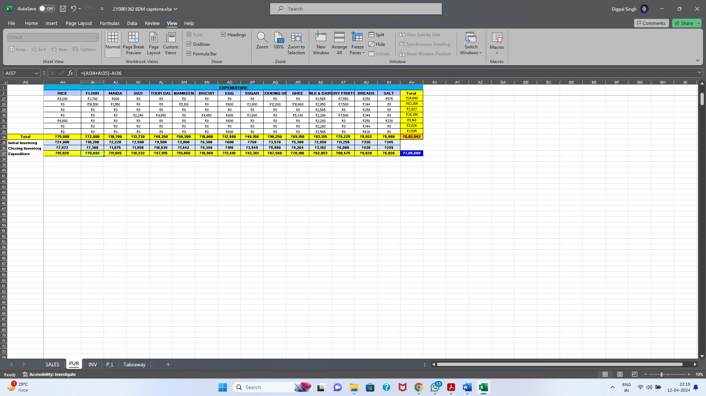

* In the end cumulative profit has been calculated to represent it in pareto chart



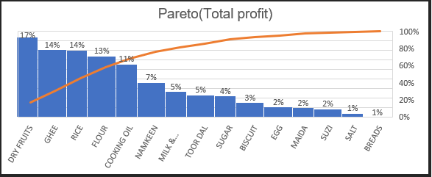

# Inventory optimization methodology:

* During discussion with owner, we came to know that inventory management was the tedious task w.r.t stockpiled-up condition in the month end, less profit and new stock buying decision.
* Hence, we collect the inventory data for each item at very first day and afterward calculated using sales, purchase, and initial inventory as per below mentioned formula:

𝐼𝑛𝑣𝑒𝑛𝑡𝑜𝑟𝑦𝑖 = 𝐼𝑛𝑖𝑡𝑖𝑎𝑙 𝐼𝑛𝑣𝑒𝑛𝑡𝑜𝑟𝑦𝑖 − 𝑆𝑎𝑙𝑒𝑠𝑖 + 𝑃𝑢𝑟𝑐ℎ𝑎𝑠𝑒𝑖

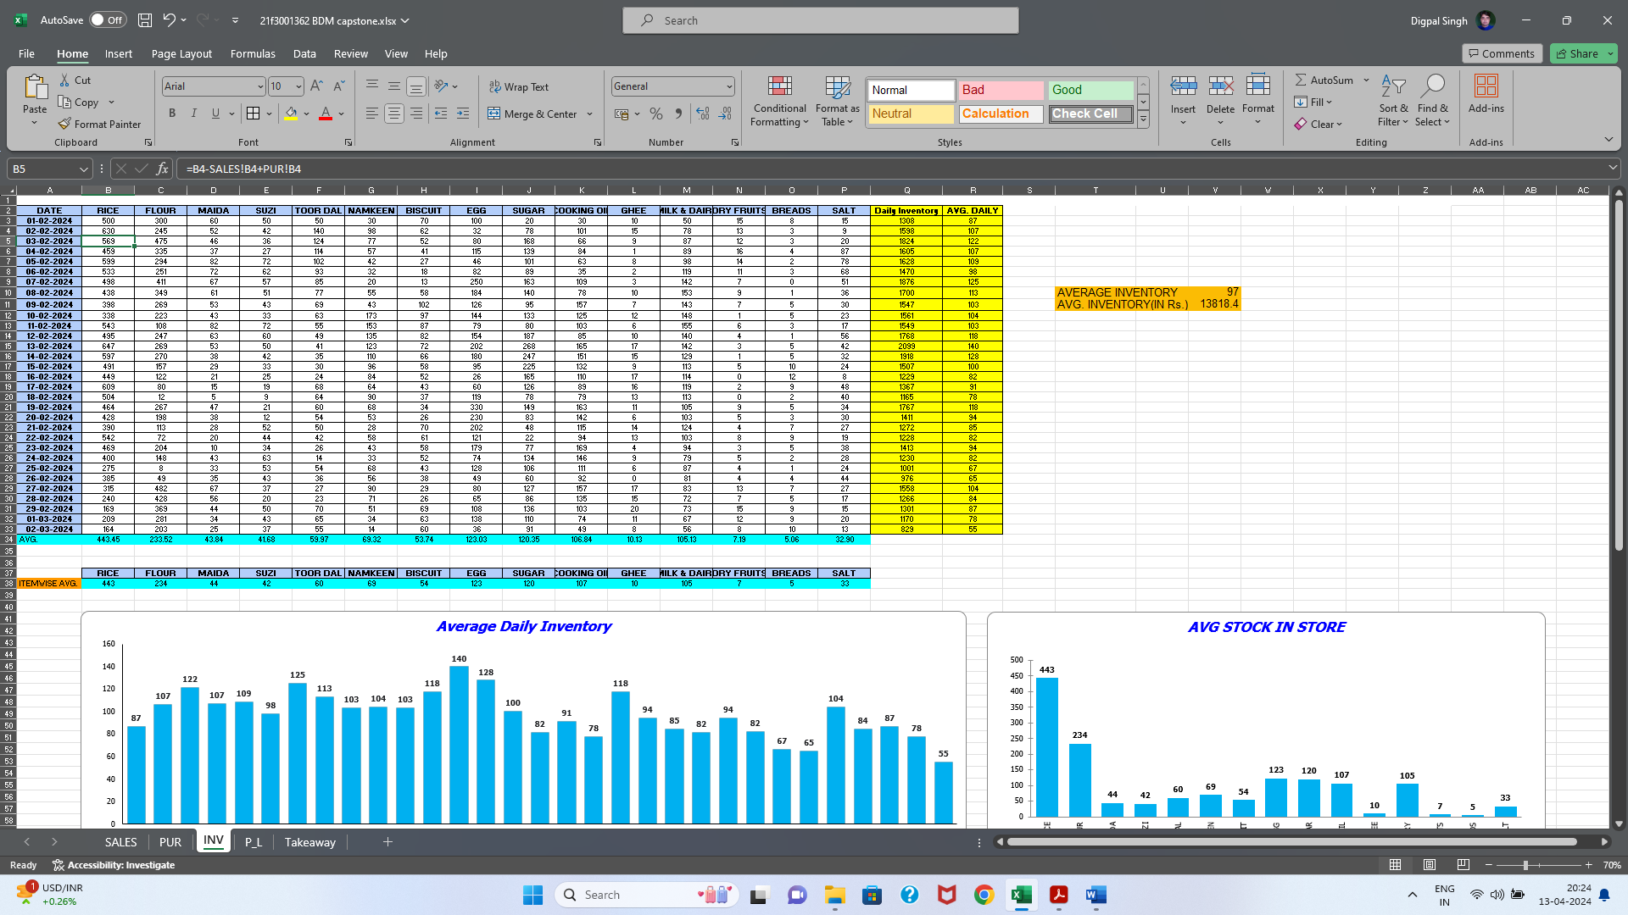

* By using above inventory data, average inventory, total inventory was calculated for each day for each item.

*Total Inventory* = *i*

*where = Inventory at ith day*

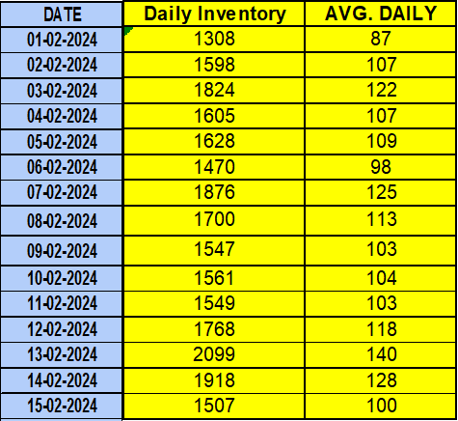

# Fixed cost analysis:

* In this analysis, we collected the data for furniture, transport, storage items, rent for a period of approx. 31 days considering the depreciation rate.
* Considering the collected data, total fixed cost was calculated.



# Results and findings:

# Sales and purchase analysis:

* Firstly, graph for revenue generated over the month, is made.
* By seeing above graph, we can say that sales are good on Saturdays as compared to other days.
* In the mid of the month, slight decline trend is visible in sales.
* If we talk about the average daily revenue generated is ₹ 26027 and Standard deviation is ₹ 4780 which not so high and we can say low level of fluctuation is visible in sales.
* Minimum revenue ₹ 17681.
* Maximum revenue ₹ 36439.
* The range of max and min is ₹ 18758.

Further, revenue generated by each item over the month and pareto chart in respect to the total revenue generated by each item over the month, has been represented.

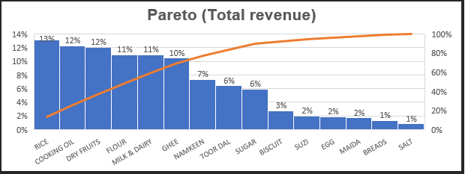

* By looking above graphs, we can say that Rice, Cooking Oil, Dry Fruits, Flour, Milk & Dairy and Ghee are the main revenue generating items over the month.
* The fact also can be seen by pareto chart as these 6 items contribute approx. 69% to the total store’s revenue.

Further, to analyse each item contribution, revenue proportion pie graph has been made along with sales volume proportion pie chart.

* By seeing above graphs, we can say that revenue proportion of each item is directly proportionate to the sales volume.
* Cooking oil, Ghee and Dry Fruits having sales volume of 6%, 1% and 1% respectively contributes 12%, 11% and 12% to the total revenue generated by the store over the month means these are high revenue generating items at a low level of sales volumes.

After sales analysis, we have analysed the fluctuation trend in purchase price as shown in below graph.

* By seeing below graph, we can say that purchase price slightly up in mid of the month which coincide with the highest revenue generating period as mid of the month.
* Dry fruits purchase price shows dip in the trend at the end of the month, means it is a best time to purchase the dry fruits to generate the maximum profit.
* On the other hand, TOOR DAAL purchase price shows slight up trend after mid of the month which shows that early stock of it will generate the greater profit.

Based on above analysis, we have plotted graphs for “Toor Daal” and “Dry Fruits” purchase price and purchase volume to analyse the buying decision made by store owner.

* By seeing above graphs, we can say that owner could increase the profit by early purchasing of “Toor Daal” and slightly delay or early purchasing of “Dry Fruits”.

# Profit / Loss analysis:

The graphs plotted over here shows the comparison of average purchase price to the average selling price for each item which further used to calculate the average profit of each item to analyse the gap areas which can be further improved to increase the net profit.

* From the above graphs, we can see that “Dry Fruits” and “Ghee” are the maximum profit generating items. On the other hand, if we look at sells volume of both the items, needs to be improved to increase the net profit of the store.

Further, we have plotted the graph to show the contribution of each item to the profit in comparison to the contribution in the revenue.

* The comparison graph validates our previous claim about “Dry Fruits” and “Ghee”.
* The above graph also indicates that “Milk & Dairy” and “Sugar” even after having enough sells volume, contribution to the net profit is lower as compared to other items.

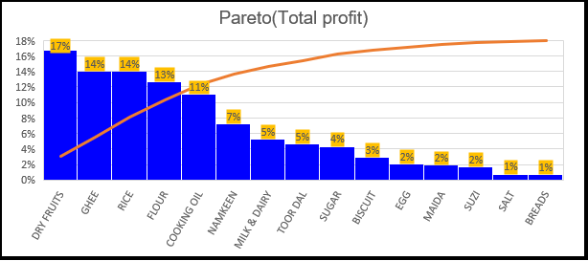To validate our above findings, pareto chart is plotted here.

* By seeing above pareto graph, we can easily say that 76% contribution to the profit is from Dry fruits, Ghee, Rice, Flour, Cooking oil and Namkeen.
* We can also validate our claim regarding “Milk & Dairy” and “Sugar” as they are not in 76%

Furthermore, graph is generated to analyse the gross profit and loss over the period of the month.

* We can say that purchasing “Dry fruits” and “Toor Daal” at right time, will increase the net profit of the store.
* It is also can be validated that after mid of the month, profit increases.
* We also can say that the stock addition in the start of the month, resulting in the lower net profit of the store.

# Inventory analysis:

To do the analysis of inventory, we plotted the graphs showing average sales and stock of each item available in the store.

* By looking at both the graphs, we can say that there is no abnormality except “Breads”.
* Rice, Flour and other items inventory is high, need to optimize the same to increase the net profit margin.

Now moving on to cater the inventory related issues, we plotted the inventory fluctuation graph over the period of month.

* By looking at above graph, we can say that there is no abnormality in average stock w.r.t sales, however, fluctuations are high in inventory for most of the items and slight dip in trend is visible after mid of the month which indicates poor planning and validate the owner’s claim of tedious task to maintain the inventory.
* Secondly, it can also be seen easily that store tends to refill its stock in relation to demand or stock is limited which can be referred to as a good practice, but it is having bad impact.

# PL & Insights:

Now to calculate the net profit, fixed cost is calculated using the data given by store owner.



* The above table provides us with fixed cost analysis along with depreciation rate (approx. given by the owner)
* Items in above table can be majorly divided into two segments: - fixed assets and monthly expenses.
* From the above table following things can also be calculated:
* Total fixed cost: ₹ 11,38,000
* Total Normalized Fixed cost: ₹ 73,200, which can be used to calculate net profit using formula:

(𝑁𝑒𝑡 𝑝𝑟𝑜𝑓𝑖𝑡 = 𝐺𝑟𝑜𝑠𝑠 𝑃𝑟𝑜𝑓𝑖𝑡 − 𝑇𝑜𝑡𝑎𝑙 𝑁𝑜𝑟𝑚𝑎𝑙𝑖𝑠𝑒𝑑 𝐹𝑖𝑥𝑒𝑑 𝐶𝑜𝑠𝑡)

* Net profit: ₹ 28,037

Further we have plotted pie chart to analyse fixed cost proportion.

* By seeing above graph, we can say that rent and electricity are the main contributors to the fixed cost but considering necessity for the shop, further reduction cannot be done.

# Interpretation of results and recommendation:

# Recommendation 1: Increase the sales of High profit items: (i.e., Dry Fruits, Ghee & Rice)

Based on the analysis, it is evident that Dry Fruits, Ghee and Rice have significantly higher profit margins compared to other items. The shop owner can take advantage of this by increasing the sales of these items, resulting in higher profits and additional assets for the shop.

**Measures can be taken to increase the sales of high profit margin items:**

* **Seasonal Promotion**: Dry Fruits are commonly consumed during winter and festive season. The shop can launch a sale on dry fruits during this season to capitalize on increased demand and boost sales.
* **B2B Platforms and Business Partnerships:** Dry Fruits, Ghee and Rice are essential items for other businesses as well. The shop can promote this by participating in B2B platforms or approaching other businesses to sell these items at a lower rate than what is offered to customers. However, this may reduce the profit margin per unit, it can significantly increase overall sales and ultimately lead to higher net profits for the shop.
* **Bulk Sales and Discounts:** Instead of selling small quantities of dry fruits and rice, the shop owner can offer larger quantities of dry fruits and rice packets at discounted prices to attract customers and other business owners. This strategy can encourage customers to buy in bulk and increase sales volume.

# Recommendation 2: Increase the sales of items having low revenue : (i.e., Breads)

In line with the first recommendation, it is important to address items like Cooking Oil, Milk & Dairy that may not be meeting sales expectations due to seasonal, time-specific, or incentive-based factors. To optimize inventory further and increase sales, the following strategies can be implemented:

* **Morning-focused Milk Sales**: Based on discussions with the owner, it was found that 95% of milk sales occur in the morning. To enhance inventory management and increase sales, the shop can prioritize stocking milk specifically for morning demand. Additionally, the shop can encourage customers to purchase other goods along with milk or offer house delivery of milk at no additional cost. This strategy can optimize fixed assets, such as delivery vehicles, and increase overall sales. Successful startups like OTIPY, Milk BASKET have employed similar strategies to boost their sales.
* **Introduce Delivery Charges:** Once the initial phase of offering free home delivery of milk is established, the shop owner can gradually introduce nominal charges for delivery. This will not only help cover the cost of the service but also generate additional profits for the shop.

# Recommendation 3: Restock inventory according to sales:

The shop owner made poor decisions in purchasing Toor Daal and Dry fruits, resulting in significant losses for the shop. These decisions were primarily influenced by high demand and low stock availability at that time. To avoid such situations and optimize inventory management, the following recommendations can be implemented.

* **Timely restocking:** Rather than purchasing and selling items based on demand, it is advisable to restock the inventory at fixed intervals. The items can be sorted based on perishable and non-perishable goods based on self-life, considering the shop's facilities and the owner's preferences. This approach allows the shop owner to identify items that can be purchased in advance, reducing the risk of making last-minute decisions.
* **Timing Restock with High Sales Periods**: By analyzing the data, it is observed that purchasing of goods considering purchase price, sometime pre-purchasing and post purchasing is beneficial to the store. Therefore, it is recommended to restock inventory slightly earlier or later to avoid making incorrect decisions due to inadequate stock. By aligning restocking with high sales periods, the shop can ensure sufficient inventory availability without excessive load or unnecessary risks.

# Recommendation 4: Increase current ratio:

The analysis reveals that the shop's current ratio (CR) is currently low, indicating potential liquidity issues. The current ratio can be improved by either increasing current assets or decreasing liabilities. (based on formula given below)

𝐶𝑢𝑟𝑟𝑒𝑛𝑡 𝐴𝑠𝑠𝑒𝑡𝑠 = 𝐼𝑛𝑣𝑒𝑛𝑡𝑜𝑟𝑦 (𝑠𝑡𝑜𝑐𝑘) + 𝐶𝑎𝑠ℎ (₹ 25000) = ₹ 38,818

𝐶𝑢𝑟𝑟𝑒𝑛𝑡 𝑅𝑎𝑡𝑖𝑜 = 𝐶𝑢𝑟𝑟𝑒𝑛𝑡 𝐴𝑠𝑠𝑒𝑡𝑠 / 𝐿𝑖𝑎𝑏𝑖𝑙𝑖𝑡𝑖𝑒𝑠 = 0.04

Considering the constraints of the scenario where household expenses rely on the majority of profits and essential liabilities for running the business, reducing liabilities is not a feasible option. Therefore, the focus should be on increasing sales to boost current assets and improve the current ratio.

By implementing the aforementioned recommendations to increase the sales of high-profit items, restocking inventory at optimal times, and targeting specific sales strategies for milk and other items, the shop owner can enhance profitability, optimize inventory management, and improve the current ratio, leading to a more financially stable and successful business.

# Recommendation 5: Additional ways:

e.1): Effective Pricing:

Another aspect to consider in increasing profitability is implementing effective pricing strategies. The shop owner can explore the following approaches:

* **Combo Offer**: Considering combo offers where related items such as rice and atta are sold together at a discounted price. This will encourage the customers to buy multiple items and increase the store’s overall net profit.
* **Promotional pricing**: Time to time special offer and promotions, such as discounts, buy one get one free, 5% less from MRP to attract the customers. These promotional pricing strategies can boost sales during specific periods or intervals.

e.2): Store’s display and visual enhancement:

Below given steps can be taken to enhance the store’s visuals and display:

* **Eye-catching displays:** Arrange high-profit items, such as dry fruits and ghee, in attractive displays near the entrance or high-man movement areas. Use creative and appealing signage or decorations to draw attention and entice the customers to explore those sections.
* **Technology inculcation**: Technology plays a vital role in every field. Hoardings, banners and screens having clear message about special offers, can draw attention and entice the customers to explore these offers.

# Conclusion:

In summary, the analysis of Shiv Shakti Mill Kirana Store's sales and expenditure data has yielded actionable insights aimed at enhancing profitability and optimizing inventory management.

Through this comprehensive examination, it became evident that certain product categories, notably Dry Fruits and Ghee, possess substantial profit potential. Leveraging targeted marketing initiatives, such as seasonal promotions and strategic partnerships, presents a promising avenue for capitalizing on these high-margin items. Additionally, incentivizing bulk purchases through discounts can further stimulate sales and bolster overall revenue.

Moreover, the assessment underscored the critical importance of refining inventory management practices. Proactive restocking during peak demand periods, coupled with refined forecasting techniques, will enable the store to maintain optimal stock levels, thereby mitigating both excess inventory costs and potential stockouts. This proactive stance ensures customer satisfaction while simultaneously optimizing operational efficiency.

Furthermore, prudent procurement practices emerged as a focal point, emphasizing the need for vigilant monitoring of market dynamics to circumvent purchasing at inflated prices, as evidenced by the fluctuations in Dry Fruits and Toor Daal costs. By adopting a proactive procurement strategy, the store can mitigate financial risks and safeguard profitability.

The scrutiny of fixed costs highlighted opportunities for cost optimization, particularly in areas such as electricity and packaging materials. Continuous evaluation and refinement of expenditure are imperative to enhance cost efficiency and safeguard profit margins.

Additionally, recommendations to enhance store aesthetics and implement effective pricing strategies are poised to elevate customer engagement and drive sales. Engaging displays, coupled with strategic pricing tactics, create a compelling shopping environment, fostering increased consumer spending and bolstering revenue streams.

By embracing these strategic imperatives, Shiv Shakti Mill Kirana Store stands to enhance its financial performance, fortify profitability, and solidify its competitive foothold within the market. It is imperative for the proprietor to maintain a vigilant stance, continuously evaluating the efficacy of these measures and adapting as necessary to ensure sustained growth and resilience in an ever-evolving market landscape.

# Important link:

Spreadsheet: [21f3001362_BDM_Capstone_Spreadsheet](https://docs.google.com/spreadsheets/d/1YzB8KFIKV9hNLhRcMfnfzGHpicy_96lr/edit?usp=sharing&ouid=107085447042616396690&rtpof=true&sd=true)

Presentation: [BDM_Project_PPT_Digpal](https://docs.google.com/presentation/d/1j7jI03DkZRQFmLhn9x95PsvVP9OiGuaO/edit?usp=sharing&ouid=107085447042616396690&rtpof=true&sd=true)

--------------------------------------------------------------------------------------------------------------------------------------------------------------------------------------------------------------------------------------------------------

**Submitted by-**

Digpal Singh

Roll Number: 21F3001362